Osteoporosis and Bone Support
January 2021

Calcium is one of the most important and abundant minerals in our bodies. Nearly all of our bones and teeth are made of calcium. Calcium also plays an important role in cardiovascular health, muscle contraction and blood clotting and enzymatic functions.
When the body is deficient in calcium, it will pull this necessary mineral from bone. A trace amount is needed for cardiovascular health and that is the body’s priority. Consequently, it is important for skeletal health that you maintain a balance of calcium with other minerals and nutrients that work together to support healthy bones, including magnesium, boron, silicon, strontium, vitamin K, and vitamin D. Of these nutrients, magnesium and vitamin D play crucial roles to activate calcium. There is a methodical trajectory to how these nutrients work together: magnesium helps vitamin D convert to its active form within the body. Calcitonin is a hormone released in the presence of vitamin D. Calcitonin works to remove calcium from the circulatory system and lay it down as bone.
Magnesium (Mg) from foods – green leafy vegetables, avocado, sunflower seeds, cashews, flaxseeds, almonds, black beans or supplemental Mg (malate, glycinate)
+
Vitamin D from the sun, fortified milk, orange juice or supplemental vitamin D3. I encourage my clients to get out in the sun for 15 minutes, every day, without sunscreen. Most of us live in areas where we can’t make enough vitamin D from sun exposure. Spending time outdoors and sun exposure are important for mood and overall health.
Calcium (Ca) bone/structural integrity
Supplemental calcium comes in several forms – calcium carbonate is the most common. However, calcium citrate is the most absorbable and requires less to be affective. Look for a supplement that combines calcium and magnesium in a 2:1 ratio. If you become constipated, you can take them in equal amounts. Your body can only absorb 500 mg of calcium at a time.

Foods to support bone health and help with osteopenia and osteoporosis:
- Green leafy vegetables are high in vitamin K and contain Ca, Mg and other minerals
  - Kale, spinach, watercress, dandelion and mustard greens, parsley, bok choy
- Make each meal 2/3 alkaline (vs. acid): avocado, sweet potato, yam, asparagus, broccoli, add lime or lemon juice to water between meals, vegetables and fruits, lentils, pumpkin seeds
- Organic, preferably locally sourced dairy products if tolerated are high in calcium
  - Whole milk, yogurt and cheeses are easier to digest than milk or ice cream
  - Sheep and goat’s dairy products are also easier to digest and often local
  - Other sources include sardines, almonds and sesame seeds, raw broccoli and kale
- Sea vegetables – add dulse to soups, salads; use organic nori sheets instead of bread or tortillas for roll-ups; wakame, kombu to soups and stews

Other minerals that support bone:
- Boron: Limits bone resorption and help mineralize bones, especially calcium.
- Sources include avocado, sweet potatoes, artichokes, walnuts, pecans and beans
- Silicon: Supports metabolic and structural functions in bone, connective tissue and cartilage. Found in whole grain cereals and root vegetables. Also found in water and water-based drinks. Molybdenum competes with silicon for absorption.

- Strontium: Naturally found in soil, but supplementation is controversial. Access this mineral from seafood, root vegetables, spinach and celery. Stick with that or consult your doctor.

- Vitamin K2, aka menaquinone: Synthesized from bacteria, sources include tempeh, liver, dark meat poultry, hard cheeses, egg yolks. Involved in regulating where calcium is distributed in the body. Combined with vitamin D3, they limit osteoclasts. Because of its role in regulating calcium, it also helps support cardiovascular function. Deficiency is common. Minimum RDA for middle aged and older women is 90 mcg and 120 mcg for men, but for those that are deficient, repletion can be >500mcg.

- Vitamin K1, aka phylloquinone: Synthesized by plants, sources are most green vegetables and raw celeriac. Deficiency is rare. Supports blood clotting and cardiovascular function. Caution for those on blood thinners.

Herbs to support skeletal health and help with osteopenia and osteoporosis:
- Horny goat weed – in addition to be being a vasodilator, it mineralizes bone. Steep loose tea leaves.
- Horsetail – high in silica – necessary for healthy bones, cartilage, tendons, and connective tissue. Horsetail also shown to be affective for hair loss, anti-inflammatory, brittle nails, and edema. Use as a tincture or use the dry herb to make a tea. Allow it to steep for 10 minutes.
** Can diminish thiamine (B1) levels and potassium – don’t use it everyday
- Nettles –mineralizes bone because it contains boron and silicon. Take as a tea or supplement and also works as an antihistamine.

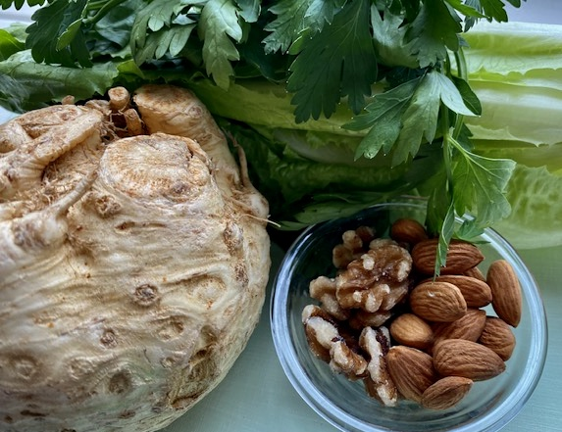
Sources:
Broadwine, Teresa, RH, AHG, Green Comfort Herbal Medicine
Duke, Dr. James A., The Green Pharmacy Herbal Handbook, St. Martin’s Paperbacks, 2000.
Gropper, Sareen S., Jack L. Smith, James L. Groff, Advanced Nutrition and Human Metabolism, Wadsworth Cengage Learning, Fifth Edition, 2009.
Lord, Richard S. and J. Alexander Bralley, Laboratory Evalations for Integrative and Functional Medicine, Metametrix Institute, Deluth, GA. Revised 2nd Edition, 2012.
https://lpi.oregonstate.edu/mic

